Before the Delusion by William Gleeson, a bombshell rewriting 12,000 years of history

By Roland Michel Tremblay

(Images/photos listing and credits at the end.)

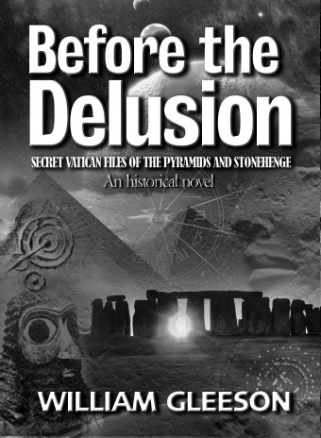
Before the Delusion: Secret Vatican Files of the Pyramids and Stonehenge is an excellent book that changes nearly everything you thought you knew about human history and the origin of religion, in particular Christianity and Judaism.

From a wide range of ancient literature and archaeological reports, Gleeson has explored our pagan history - our ‘real’ history before it was Christianised, before it was misunderstood, mistranslated and just plain distorted to serve the interests of the Church. He has recovered the fragments of factual history from a surprising variety of sources - the Egyptian Pyramid Texts, the Hebrew Old Testament, the Greek myths, the Celtic Mabinogion, Grimm’s Household Tales and modern-era archaeological reports - and cleverly rewoven these threads into a coherent and persuasive picture of ‘alternative’ history. Actually our real history.

There are of course numerous books that have been written about theology and what those pyramids in Egypt and the Ziggurat temples in Iraq and Iran were for; the same for the megalithic structures like Stonehenge found in England. You read these interesting books but at the end you are often left with a question mark, wondering if it could be possible at all. Is it not remarkable that these huge structures and why and how they were built still remain a mystery today?

Twelve percent of Before the Delusion (The Temple Publications, UK), is all the author’s references and the bibliography; it is extensively substantiated with evidence that can be found on the Internet. It is also a Dan Brownish novel like Da Vinci Code but everything in the background is true. The novel is a device to alleviate what could have been a dry subject. I don’t intend to tease anyone, I will tell you what the book is about, probably inviting ironic comments in the process but bear with me, and I will follow with an interview with Bill Gleeson.

Essentially if you read carefully the ancient texts and mythology you will find that it corresponds to what can be deciphered on the ground with all the megalithic structures found all over Britain, including also Ireland, Scotland and France. Far from being stories of heroes on a sea voyage, knights in armour fighting armies, you can discover that the main thread is instead a celestial history of our solar system recording the planet formations and collision impacts for thousands of years.

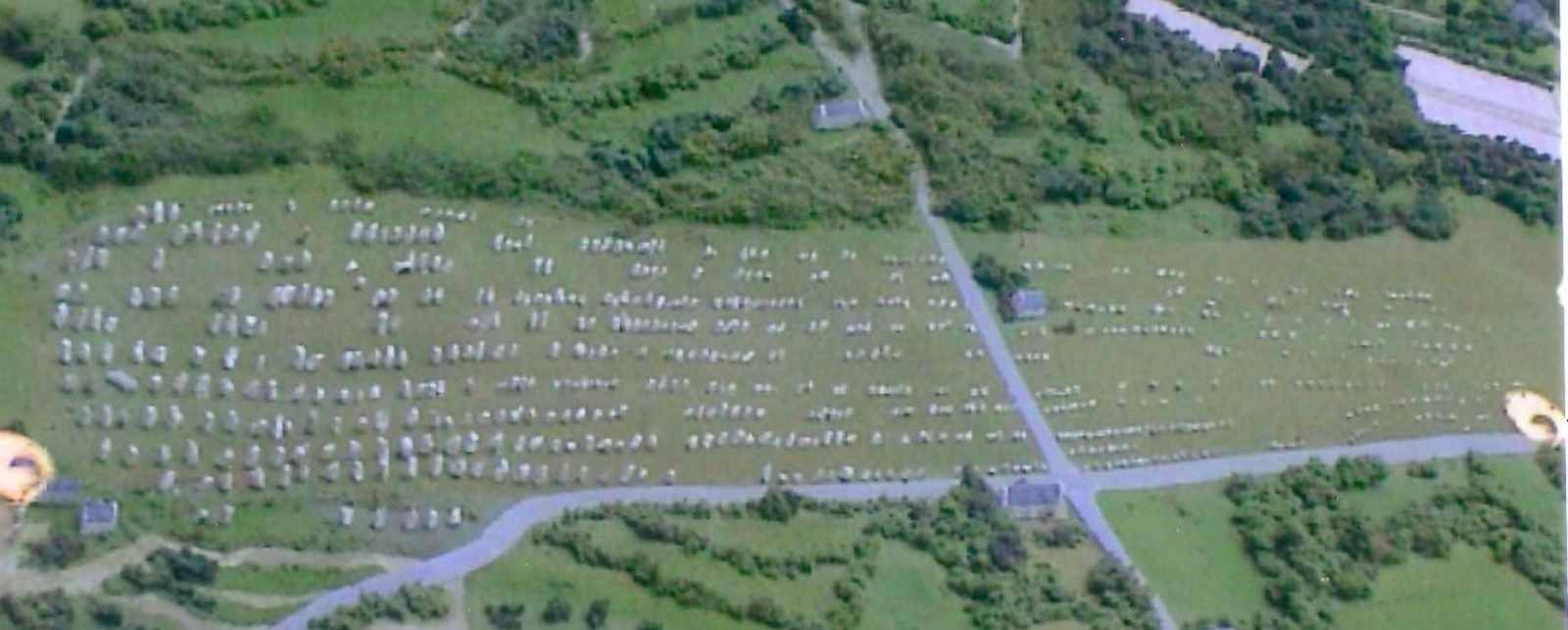
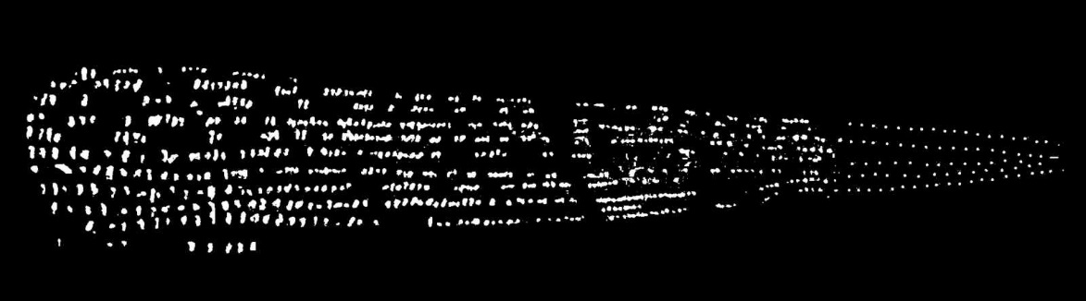

The whole puzzle of the megalithic rocks starts with Carnac in France where on the ground you can see the design of comet trails made of multiple stones. This is the starting point of the journey of the comet originating from the Vela constellation (according to the site at Woodhenge near Stonehenge) that will extend to several planets of our solar system including: Newgrange in Ireland (Saturn and Uranus), Anglesey island (Neptune), the Hebrides and Orkney islands in Scotland (asteroid belt), Montmartre in Paris (Mont Mercury), Mont Saint-Michel in Normandy (Jupiter), Salisbury (Mars), Hatfield barrows (Earth), Marlborough (Venus), White Horse (Mercury) and Silbury Hill/Avebury (Sun).

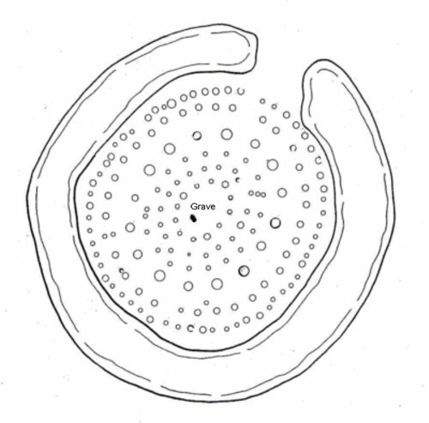
Other sites tell the story of other collision impacts, planet formations and constellations, and show the trajectory of the comet. Numerous smaller stones around such sites correspond to the atomic number or atomic mass of elements of the periodic table. For example the 56 peripheral ‘Aubrey Holes’ at Stonehenge indicate iron, probably referencing the composition of an ironstone meteorite (the iron-hearted hero of Greek myths). The post holes of Woodhenge are arranged in a pattern of 64+93=157, which is the atomic structure of gadolinium [64 P, 93 N, atomic mass = 157] characterising a highly magnetic neutron star which is the typical remnant of a supernova.

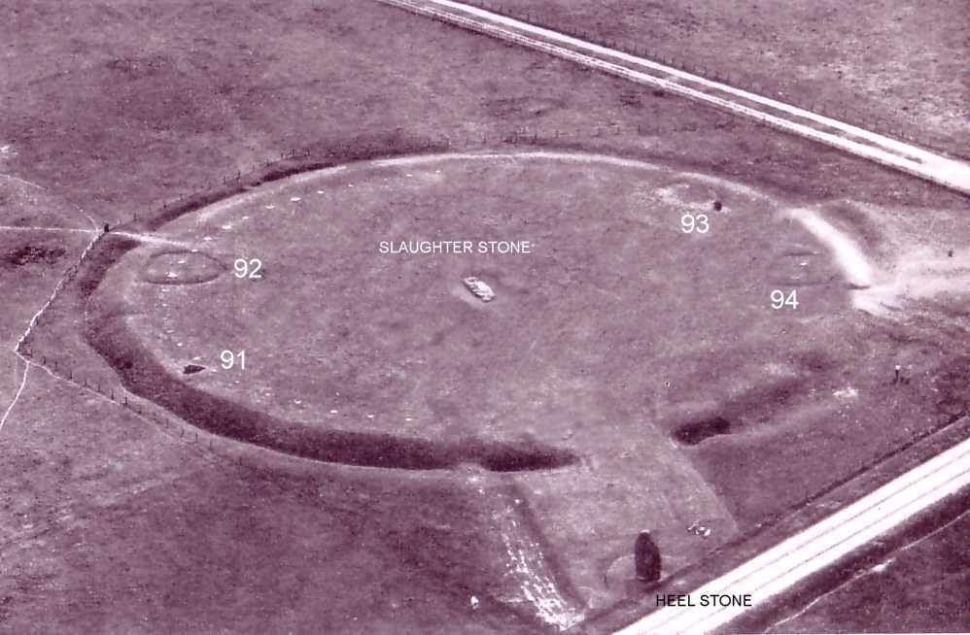

The early configuration of the Stonehenge circle is the key, it is a map that shows us where the comet or asteroid fell on Earth 12,000 years ago. The two earth mounds with holes at their peak at the periphery of the circle correspond to the highest volcanic craters on their respective coasts: Mount Chimborazo in Peru and Mount Fuji on Honshu Island. The two main stones at the periphery correspond to the highest mountains on the Pacific Rim: Mount Whitney, North of Los Angeles, and Mount Pucak Jaya in Papua, Indonesia.

The Stonehenge middle stone also known as the Slaughter stone marks where the comet fell on Earth (the intersection of these four highest points): exactly on the other side of the planet in the middle of the Pacific Ocean. This is evidenced by the high Rockies and mountains all around the Pacific Rim and the central rebound of the impact forming the Hawaiian Islands. Hawaii’s tallest mountain, Mauna Kea, is the highest on Earth when considering 4205 meters above water and 5000 meters below.

That same story can be followed and compared with the Greek mythology in the Iliad and Odyssey of Homer and Aeneid from Virgil, also in the King Arthur’s tales and even children’s tales like Hansel and Gretel (Mercury and Venus) and Sleeping Beauty (Earth). Even the Old Testament tells parts of this epic celestial story.

The people who built this elaborate puzzle out of megalithic structures in Europe are the same who built the pyramids and the Ziggurat temples. They were the Lords of Ur, also known as the antediluvian Kings (from before the flood), who suddenly appeared in Sumeria (Iraq) before 3000 years BC. They are referenced in many biblical texts, especially before Christianity erased any mention of these Lords (plural) to replace them with the one God. However the story remains when you consider more direct and early translations of these texts.

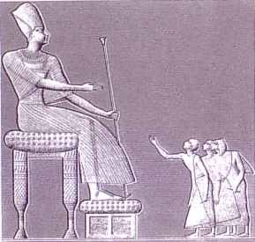
The Lords of Ur were giants (always represented at least twice bigger than normal humans) who could live a thousand years, although they gradually lived younger due to interbreeding with normal humans and unhealthy radiation. They were also the forefathers of the Israelites. Their well-known descendants include Adam, Eve, Abraham, Moses, David, Solomon and Jesus Christ.

It is unknown if the Lords of Ur were descendants of the inhabitants of the continent that disappeared after the comet’s impact in the Pacific Ocean (possibly referred to by Plato) or if originally they might not have been from Earth at all. Gleeson’s research indicates that already in 3000 BC records of their kingdom went back at least 10,000 years; and that some are probably buried at Pohnpei Island in Micronesia and could still be discovered by exploration. There are proofs of the existence of these giants from Egyptian tombs that have been uncovered and their longevity is also clearly confirmed in the Bible.

The ‘God’ of the Israelites was ‘light’, produced by nuclear reaction. All the pyramids and Ziggurat temples were nuclear power stations pumping water from the Nile and the Euphrates rivers to become steam generators providing rain and fertilization. Chemical and mechanical engineers have independently reached a similar conclusion and they explain exactly how it works at nuclearpyramid.com (http://nuclearpyramid.com/great_pyramid.php).

The purpose of these stations was to clear the sky after the comet’s impact 7000 years before from impact debris and volcanic ash; steam being a strong greenhouse gas causing warming, and rain physically cleansing the lower atmosphere. They brought light to darkness from a clouded sky. This is when everyone was advised to leave Egypt for 400 years, many Lords of Ur reaching the UK.

The flood was a ‘wind flood’ of nuclear radiation. Previous Egyptologists mistranslated the wave hieroglyph for water when it actually meant ‘waves’ of radiation. Noah (Babylonian Utanapishtim or Ziusudra) did not build an ark, he built an arx, which was a huge building well insulated against radioactive waves. He was told 100 years before that he would need to build it, so possibly it took 100 years to build the Temples of the Sun (pyramids) and the Temples of the Moon (Ziggurats).


There is only one inscription that could be found on the Great Pyramid of Cheops in Giza and it is the equation E=mc² written in reverse in early-style symbols. “The word was god; HE=mc²”. Gleeson explains well in the book how he translated the equation from ancient texts but summarily: the first symbol, ‘V’, was a form of the later hieroglyph represented as uplifted human arms or animal horns, denoting ka – a difficult concept interpreted uncertainly as a ‘double’ or ‘duality’; a multiple of itself. The second symbol of the complete circle, ‘O’, represented completeness, wholeness or entirety. The third symbol of three parallel horizontal lines intuitively conveyed the still universal meaning of ‘equals’ or ‘equivalent to’. And the fourth symbol, of a divided circle, may be interpreted as something divided or split.

Gleeson even identified the exact location where the uranium was mined (Kerma in Nubia) and also the place where it was enriched (Abydos), where such elaborate installations have been excavated and reconstituted. Later the Israelites and Babylonians had nuclear weapons of mass destruction; examples of such radioactive weapons were the Holy Grail and the Ark of the Covenant. It explains why so much evidence of nuclear explosions like sand and pottery turned to glass has been found. It has also been proven in 2010 that chambers in certain pyramids are still radioactive today, to unhealthy levels.

God did not separate the water of the Red Sea, but the radioactive wave did open a pathway by killing the Egyptian army for the entire host to pass through. It is clear from the Old Testament that what they used to destroy these enemy armies or cities like Sodom and Gomorrah was radiation, and that all the signs of radiation poisoning are there (especially pustulous leprosy and plagues).

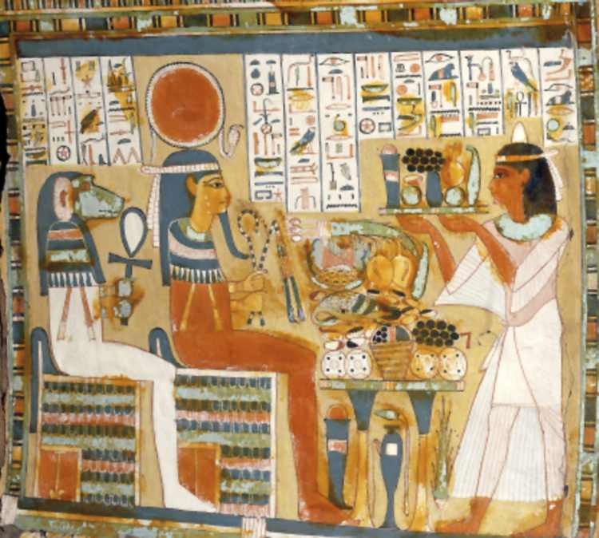

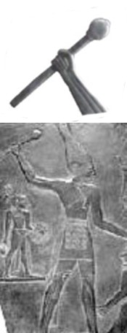
The lapis lazuli crystal stones from Afghanistan that were contained in the so-called sarcophagi in the pyramids or thrones of the Egyptian Lords, were arranged 7 X 7 X 7 along with the enriched uranium, and were later enclosed in a gold shell (insulator) attached to a hollow tube like a rifle barrel. There are plenty of examples in museums of these nuclear weapons ‘rods’, it is not clear however if they are the real weapons or later ceremonial imitations.

This may sound just unbelievable and too much to accept. It is up to you to read the book Before the Delusion, research the evidence and make your own mind up. Several other authors have written fascinating books complementing this research, like Graham Hancock, Robert Bauval, Robert K. G. Temple, David Rohl, Alan F. Alford, Christopher P. Dunn, Scott Creighton and Gary Osborn. No point in criticising this without reading the book. If other experts eventually verify Gleeson’s findings, his book will certainly be key to our history. And now I will let Bill Gleeson answer a few questions.

Roland Michel Tremblay: 1) William Gleeson, a few months ago your book Before the Delusion was published in the UK. You make extraordinary claims in this novel that you have researched for 15 years. Not being an expert yourself, can you tell us what prompted you to write the novel?

William Gleeson: I have a very, very sceptical nature. Extreme. I have read ancient history and archaeology for 20 years, during the course of which I noticed factual or logical anomalies - stuff that just doesn't make any sense. So I began keeping a list until eventually I had enough material that formed patterns with alternative explanations. Gradually over 10-15 years I pieced together an alternative story - supported by evidence. I didn't just make up an alternative story - I discovered the pieces and assembled it from prior records.

I had about three attempts at writing it. I tried as non-fiction but that was too boring - then I tried twice as fiction. In Before the Delusion I have used a fictional Vatican scholar as a literary device to carry the story. He is fictional but the content is factual and documented. Anyone can check it from public sources.

RMT: 2) Can you tell us in your own words what the novel is about?

WG: It is about pagan pre-Christian history - our human history for about 3000 years from ancient Babylon and Egypt up until Christianity. Then when Christianity was introduced - made compulsory by Emperor Theodosius in AD 390 - everything pagan was destroyed. All the old records were literally deliberately burned. Temples and monuments were smashed. Our real history was destroyed and replaced by Christian doctrine.

RMT: 3) You talk about ‘anomalies’ - what does that mean, can you talk about examples?

WG: Yes I mean items or events that are logically inconsistent or inexplicable – at odds with the orthodox paradigm. For example there was an iron plate and a bronze hook found inside the Great Pyramid - that are now in the British Museum. They were from inside the Great Pyramid, meaning at a date that is before the Iron Age and Bronze Age by about 1000-2000 years. And there is no tin in Egypt from which to make bronze.

Another example - in a study run by a Harvard professor, carbon C-14 dating of the mortar of the Great Pyramid shows it dates to about 3000 BC – which is about 400-450 years older than Pharaoh Cheops. Everyone knows that. And parts of the Great Pyramid and adjacent pyramid show saw cuts and drill holes in granite and even basalt - made by diamond tipped instruments. Quite clear and recorded by none other than Professor Flinders Petrie, the father of Egyptology.

And - the Great Pyramid was never a tomb. Again the professional academic Egyptologists know that. They call them ‘symbolic’ tombs because they know no bodies or mummies or skeletons were ever found in them. Even in several examples of closed sealed chambers - they were all empty.

Recently in 2010 parts of the Great Pyramid have been found to be radioactive - quite strongly radioactive. Back in the 1800s early European explorers recorded that the ‘natives’ told them the pyramids were dangerous because of invisible evil spirits - which the explorers laughed at as superstitious belief in ghosts. Those are just small examples - which some people dismiss as individual errors. But there are dozens of such cases - so many that when you add them all up the total weight is hard to ignore.

A much more important example is the emergence of the Sumerians in Mesopotamia before about 4000 BC. All the orthodox history says the eastern Mediterranean area was in a completely normal Neolithic state up until about 10,000 BC with just scattered small tribes of primitive hunter-gatherers. Then there was a gap of about 2000 years with no records of activity at all. Then somewhere around 6000-4000 BC the Sumerians and their cousins in Lower Egypt appeared - suddenly out of nowhere. They called themselves ‘Sumeru’ meaning civilised lords.

Suddenly there were sophisticated people with language and numbers; codified law, brick construction; fine pottery and exquisite jewellery; domesticated animals and agricultural crops. It was magic – material and cultural civilisation just appeared out of nowhere.

And the early records of skeletons showed the newcomers were physically much taller and different from the natives. They were immigrants. All this is on the orthodox record up until about 1950. Clearly the eastern Mediterraneans - from whom we are all descended - did not evolve by gradual Darwinian evolution. They just appeared suddenly.

RMT: 4) When you were writing that the pyramids were essentially nuclear reactors powering huge steam generators, and that the God of the Israelites was the light of these reactors; also that the Israelites had nuclear weapons in the 3000 years preceding the venue of Jesus Christ, how did you think it would be received by all these experts and everyone in general?

WG: At first I thought it was so clear, so obvious, with so much evidence that everyone would just say ...gosh, why didn't we see that before. But later I realised it was so radical that no one would believe it at all and instead think I must be a total fruit-cake.

But it is absolutely clear cut. The original Egyptian texts say the pyramid was a machine that accomplished the transformation of the dead body into the light of the sun. Those are not my words - that is a quote from a Harvard professor. I am not making any of it up, it is in the standard translations of the Egyptian texts.

The evidence that they were nuclear reactors is overwhelming, clear, unambiguous. The Egyptian literature itself is called ‘instructions for making a great light’; from ‘light food’ of saffron [yellow] cake in portions of 2-3-5 [Uranium 235]; and the Great Pyramid is known to be still radioactive. Quite strongly radioactive.

Ironically there was early ‘native’ literature that said a chamber of the Great Pyramid enclosed the secrets of the disintegration of matter. But that was not in English so it was regarded as unreliable.

RMT: 5) Who are these Lords of Ur from Sumeria (Iraq) who built the pyramids and the megaliths in Europe and are the forefathers of the Israelites? Where did they come from, and how did they have advanced knowledge of chemistry and nuclear technology?

WG: The texts - Babylonian, Egyptian and Hebrew - say they were civilised lords from across the sea. They were tall, long-headed and long-lived [called ‘mighty’ and ‘ancient of days’ in Biblical terms].

All that was accepted in pagan times. Even a father of the Church, Bishop Eusebius, acknowledged the mighty lords of old as antediluvian. The Old Testament Bible spoke numerous times of ‘giants’, which was re-translated into ‘mighty men’ in the King James Version (KJV). Flavius Josephus in the Antiquities of the Jews made a point of explicitly describing ‘giants with bodies so large, countenances so different from other men, that they were surprising to the sight and terrible to the hearing’. They must have been human or humanoid because they interbred freely with locals - that is clearly recorded in the KJV and even more explicitly in the Book of Enoch in the Dead Sea Scrolls.

The wife of Lamech, son of Methuselah, bore a son whose body was ‘white as snow and red as the blooming rose’, with long locks of fair hair and beautiful eyes. Lamech exclaimed in fright ‘I have a strange son, diverse from and unlike man, resembling the sons of the lords of heaven …his nature is different and not like us’ and he went to his wife and accused her, ‘have you conceived by one of the sons of heaven?’ But naturally she denied it.

The ‘lords’ came from Troy or Atlantis - the city of man that was destroyed by a catastrophic asteroid impact in ca 10,000 BC. All that is detailed in Homer’s Iliad and Vergil’s Aeneid and many other sources. Cassandra warned of celestial disaster – at which Aeneas rescued the sacred fire of the hearth and with a few kin sailed away before impact. The exact site of the original Troy was recorded in the map formed by the original Stonehenge. One princely ‘son’ figure sailed away from Troy carrying the sacred light – while later another princely ‘son’ arrived in Mesopotamia bearing the light of resurrection.

RMT: 6) An army of scholars has spent hundreds of years studying and translating the very same texts you did, why do you think no one saw what you saw in these ancient texts?

WG: Several reasons. No one much studies old literature any more – it’s not useful or fashionable. The few people who do are either orthodox University scholars or even more orthodox religious scholars. It’s not in their nature or interests to be unconventional. It took over 40 years for orthodox scholars to translate the Dead Sea Scrolls - and even then the obvious record of interbreeding was disingenuously characterised as ‘coded astrology’.

On the technology front the early explorers simply didn't know. The natives said the pyramids housed invisible evil spirits - which European explorers thought must be ghosts, we didn’t even know about radiation until Rontgen discovered X-rays and Curie identified radium in the late 1800s.

There was also some innocent or possibly deliberate mistranslation. In the KJV Bible the Hebrew plural Elohim [lords] has been deliberately re-interpreted as singular God. Literal ‘giants’ are mistranslated as ‘mighty men’. And the two great lights of brilliant crystals were transposed into the sun and the moon and the stars. Mainly we didn’t see it because we didn’t want to see it.

RMT: 7) Is there anything you left out of your novel that you felt would have been just too much and would have hurt its credibility? Can you tell us what?

WG: Yes a lot of detail - the book is only about half of it. I have left out an enormous volume of supporting material from Babylonian literature, Gnostic literature from the Nag Hammadi library, a lot of Celtic mythology and Norse mythology - both of which are very parallel to Greek mythology. To a degree that missing material is very supportive – it adds volume and weight – but it would be too repetitive and too dense. I have tried hard to be simple and brief.

If anyone wants more myth and folklore there’s a good commentary on Norse myth in de Santillana's Hamlet's Mill; and a compilation of European folklore in Frazer's Golden Bough. But they are both very dense.

RMT: 8) What else have you uncovered through all your research, is there another book brewing inside of you that you intend to write? If so, what will it be about?

WG: Possibly – there is a mountain of allegorical material in Greek, Celtic and Norse mythology which can now be made sense of.

I have also figured out exactly how the Great Pyramid worked – mechanically. There is enough information to actually re-activate or replicate the Great Pyramid. In true scientific method it would be possible to actually test the hypothesis. Incidentally, the mechanism could potentially be used to generate energy – or unfortunately to make weapons.

RMT: 9) Your novel could be considered in the style of Dan Brown’s Da Vinci Code, although your research appears more credible, and there is less action. Was it your intention, were you hoping the book would have a similar impact?

WG: I at first tried to write as straight non-fiction but it was too bland, boring and dense. I did not consciously seek to emulate Dan Brown – far from it. But I did try to construct a structure and a thread to carry a story and simply to make it more readable.

I have deliberately detailed the bibliography and footnoted almost all references so everything can be verified. In a sense this is not my story – I have not made it up – I have merely discovered and re-presented it. As my main character Liam Kelly said, ‘I have lapsed into logic and lucidity leading me to believe factual evidence of rational explanations of history. However, if anything was not well said, that is to be attributed to my ignorance'.

Roland Michel Tremblay
www.themarginal.com

Photos/Images Credits:

1) Before_the_Delusion_William_Gleeson.jpg - Book Cover from Temple Publications
www.thetemplepublications.co.uk/Books/TemplePublicationsBeforetheDelusionWilliamGleeson.html
2) Carnac_Comet_A.jpg and Carnac_Comet_A_BW.jpg - Photos by William Gleeson
www.beforethedelusion.com
3) Woodhenge_pattern_gadolinium.jpg - Diagram credit: After Cunnington, M. Woodhenge, 1929
4) Original_Stonehenge_1.jpg - ca 3100 BC. Credit: reconstructed from photo by J K St Joseph in Newall, Stonehenge Wiltshire, 1953
5) Egyptian_Lord.jpg - Egyptian 'Lord' receiving native supplicants. Picture credit from Description de l’Egypte, 1822
6) Vo-O_E-mc2.jpg - Picture of Vo=O in hieroglyphs, which translates [in reverse] as E=mc². Picture credit is from Pochan, A. The Mysteries of the Great Pyramids, Avon, 1971 and Lemesurier, P. The Great Pyramid, 32, Element Books, 1987
7) Egyptian_sun_gods_seated_on_thrones_of_lapis_lazuli.jpg – The power was in the throne. Picture credit: Coffin of Djedkhonsuefankh ca 950 BC. Trustees British Museum, image 35299001
8) Narmer_composite.jpg - From the Narmer palette. An early Egyptian King brandishes his magic rod of fiery power.

