Global Positioning System

I INTRODUCTION

Global Positioning System (GPS), space-based radio-navigation system (see Navigation), consisting of 24 satellites and ground support. GPS provides users with accurate information about their position and velocity, as well as the time, anywhere in the world and in all weather conditions.

II HISTORY AND DEVELOPMENT

GPS, formally known as the Navstar Global Positioning System, was initiated in 1973 to reduce the proliferation of navigation aids. GPS is operated and maintained by the United States Department of Defense. By creating a system that overcame the limitations of many existing navigation systems, GPS became attractive to a broad spectrum of users. GPS has been successful in classical navigation applications, and because its capabilities are accessible using small, inexpensive equipment, GPS has also been used in many new applications.

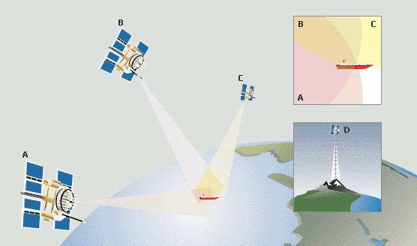
© Microsoft Corporation. All Rights Reserved.

Finding Location with GPS
Global Positioning System (GPS) satellites orbit high above the surface of Earth at precise locations. They allow a user with a GPS receiver to determine latitude, longitude, and altitude. The receiver measures the time it takes for signals sent from the different satellites (A, B, and C) to reach the receiver. From this data, the receiver triangulates an exact position. At any given time there are multiple satellites within the range of any location on Earth. Three satellites are needed to determine latitude and longitude, while a fourth satellite (D) is necessary to determine altitude.

III HOW GPS WORKS

GPS determines location by computing the difference between the time that a signal is sent and the time it is received. GPS satellites carry atomic clocks that provide extremely accurate time (see Clocks and Watches: Atomic Clocks). The time information is placed in the codes broadcast by the satellite so that a receiver can continuously determine the time the signal was broadcast. The signal contains data that a receiver uses to compute the locations of the satellites and to make other adjustments needed for accurate positioning. The receiver uses the time difference between the time of signal reception and the broadcast time to compute the distance, or range, from the receiver to the satellite. The receiver must account for propagation delays, or decreases in the signal's speed caused by the ionosphere and the troposphere. With information about the ranges to three satellites and the location of the satellite when the signal was sent, the receiver can compute its own three-dimensional position.

An atomic clock synchronized to GPS is required in order to compute ranges from these three signals. However, by taking a measurement from a fourth satellite, the receiver avoids the need for an atomic clock. Thus, the receiver uses four satellites to compute latitude, longitude, altitude, and time.

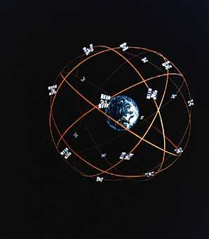
NASA

GPS System
The Navstar Global Positioning System (GPS) is a network of 24 satellites in orbit around the earth that provides users with information about their position and movement. A GPS receiver computes position information by comparing the time taken by signals from three or four different GPS satellites to reach the receiver.

IV THE PARTS OF GPS

GPS comprises three segments: the space, control, and user segments. The space segment includes the satellites and the Delta rockets that launch the satellites from Cape Canaveral, in Florida. GPS satellites fly in circular orbits at an altitude of 20,100 km (12,500 mi) and with a period of 12 hours. The orbits are tilted to the earth's equator by 55 degrees to ensure coverage of polar regions. Powered by solar cells, the satellites continuously orient themselves to point their solar panels toward the sun and their antennas toward the earth. Each satellite contains four atomic clocks.

The control segment includes the master control station at Falcon Air Force Base in Colorado Springs, Colorado, and monitor stations at Falcon Air Force Base and on Hawaii, Ascension Island in the Atlantic Ocean, Diego Garcia Atoll in the Indian Ocean, and Kwajalein Island in the South Pacific Ocean. These stations monitor the GPS satellites. The control segment uses measurements collected by the monitor stations to predict the behavior of each satellite's orbit and clock. The prediction data is uplinked, or transmitted, to the satellites for transmission to the users. The control segment also ensures that the GPS satellite orbits and clocks remain within acceptable limits.

The user segment includes the equipment of the military personnel and civilians who receive GPS signals. Military GPS user equipment has been integrated into fighters, bombers, tankers, helicopters, ships, submarines, tanks, jeeps, and soldiers' equipment. In addition to basic navigation activities, military applications of GPS include target designation, close air support, “smart” weapons, and rendezvous.

With more than 500,000 GPS receivers, the civilian community has its own large and diverse user segment. Surveyors use GPS to save time over standard survey methods. GPS is used by aircraft and ships for en route navigation and for airport or harbor approaches. GPS tracking systems are used to route and monitor delivery vans and emergency vehicles. In a method called precision farming, GPS is used to monitor and control the application of agricultural fertilizer and pesticides. GPS is available as an in-car navigation aid and is used by hikers and hunters. GPS is also used on the Space Shuttle (see Space Exploration: Space Shuttle). Because the GPS user does not need to communicate with the satellite, GPS can serve an unlimited number of users.

V GPS CAPABILITIES

GPS is available in two basic forms: the standard positioning service (SPS) and the precise positioning service (PPS). SPS provides a horizontal position that is accurate to about 100 m (about 330 ft); PPS is accurate to about 20 m (about 70 ft). For authorized users—normally the United States military and its allies—PPS also provides greater resistance to jamming and immunity to deceptive signals.

Enhanced techniques such as differential GPS (DGPS) and the use of a carrier frequency processing have been developed for GPS (see Carrier Wave). DGPS employs fixed stations on the earth as well as satellites and provides a horizontal position accurate to about 3 m (about 10 ft). Surveyors pioneered the use of a carrier frequency processing to compute positions to within about 1 cm (about 0.4 in). SPS, DGPS, and carrier techniques are accessible to all users.

The availability of GPS is currently limited by the number and integrity of the satellites in orbit. Outages due to failed satellites still occur and affect many users simultaneously. Failures can be detected immediately and users can be notified within seconds or minutes depending on the user's specific situation. Most repairs are accomplished within one hour. As GPS becomes integrated into critical operations such as traffic control in the national airspace system, techniques for monitoring the integrity of GPS on-board and for rapid notification of failures are being developed and implemented.

VI THE FUTURE OF GPS

As of March 1994, 24 GPS satellites were in operation. Replenishment satellites are ready for launch, and contracts have been awarded to provide satellites into the 21st century. GPS applications continue to grow in land, sea, air, and space navigation. The ability to enhance safety and to decrease fuel consumption will make GPS an important component of travel in the international airspace system. Airplanes will use GPS for landing at fogbound airports. Automobiles will use GPS as part of intelligent transportation systems. Emerging technologies will enable GPS to determine not only the position of a vehicle but also its altitude.

Contributed By:Leonard R. Kruczynski

Microsoft ® Encarta ® Reference Library 2003. © 1993-2002 Microsoft Corporation. All rights reserved.

