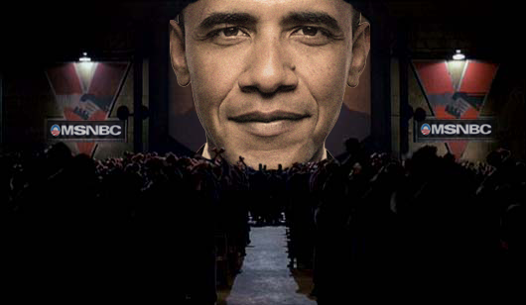

Is Barack Obama the New Savior or the Anti-Christ or Just Another Political Puppet? Martha Rose Crow

"The Messiah is absolutely speaking." Nation of Islam leader Louis Farrakhan http://blackpoliticalthought.blogspot.com/2008/10/louis-farrakhan-says-of-obama-messiah.html

"In many ways, he's sent from God, because the world's a mess…" Sting
http://www.starpulse.com/news/index.php/2009/10/29/sting_obama_was_sent_from_god_

Tell me, tell me, why was Obama born?
Tell me, tell me, why was Obama born?
Somebody had to inspire our youth
Somebody had to hear every voice
Somebody had to tell the truth
That’s why Obama was born, my lordy,
That’s why Obama was born.
From a gospel song by Dorothy Cotton

Introduction

As a researcher and writer about evil (human and ethereal/spiritual), I run into articles all the time proclaiming that President Barack Obama is either the new savior or the anti-christ, a person or persona proclaimed as the ‘new savior’ until his demonic deeds are exposed and his real mask is ripped away to reveal the personal of pure evil and psychopathy.

It’s obvious that Obamae has become a tool for the evil, entrenched powers of America and England. He hasn’t closed the prison in Guantanamo. He hasn’t stopped torture or closed black prisons around the world where the torture takes place. Obama has done nothing to stop land mines or wars. In fact, he’s escalated the war in Afghanistan and started covert wars in Pakistan and Yemen plus saber rattling for a war in Iran.

Wal-street (caustic and critical pun intended) and its corrupt captains of free-market capitalism are still running rampant with less restraints than ever. More, many of them are running government financial departments within the government: Almost all appointed by Obama himself.

The media tried to spin it that Obama facilitated ‘progress’ at the Climate meetings in Copenhagen but with closer inspection, the climate meeting was a veiled attempt to force cap and trade taxes on western countries to fund a world government through the world bank while killing countless tens of millions of third-world people because more of the world’s crops would have gone into biofuel instead of food to feed the hungry. Growing food for fuel would have raised food prices so high that the poorest of the poor wouldn’t have been able to afford food, not even mud cakes. More, ‘cap and trade’ would have spawned a new derivative market so the masters of disasters on wal-street could have ripped the world off in a new scam.

Unemployment is as high as 24% although it’s being reported at 10.5%. There are six applicants for each new job available. More and more people are losing their homes. More and more people are homeless and on food stamps. Yet, Obama does very little to help them.

Health care is a Basic Human Right and so far, ‘Obamacare’ does little to offer any real affordable health care insurance to regular people. Instead, ‘Obamacare’ will enrich wal-street insurance companies by forcing people to buy expensive insurance policies and/or paying expensive co-pays, making it so expensive that many people will not go to the doctor until it is too late. This is third-person, soft-kill genocide.

"I didn't campaign on the public option." -- President Obama on Dec. 22, 2009, expecting the public to forget that his presidential campaign platform explicitly promised to pass health care legislation giving all Americans "the opportunity to enroll in new public plan." (http://thinkprogress.org/2009/12/22/obama-repeatedly-touted-public/)

Do acts of evil imply an evil individual? Yes. Do acts of willful ignorance (if this is Obama’s case) imply an evil individual? Of course.

A very good friend suggested to me recently that Obama’s generals and the CIA have threatened him and that is why he tows the establishment line. She said that every president has that problem and if they don’t tow the line, they will be assassinated. This could very well be true but my argument is: Obama is one smart cookie and he knew what he was getting into.

Then there is the legendary CIA ‘drug patch’ problem where the CIA supposedly puts some kind of medical patch on people to control them. The patched person must do what they’re told to do so they can get a new patch within 72 hours. If they don’t get the patch, they die. Has Obama given any bare chest shots to the media lately?

Of course, Obama’s family could have been threatened if he didn’t ‘play ball’ with the hidden puppet masters. There’s all kinds of possibilities why Obama is keeping the corrupt systems corrupt or helping them become more corrupt. Because most people are good, they forget the other side of this: Maybe Obama has become corrupt by power or maybe he was just a good liar in the beginning and/or both.

The paragraphs above beg timeless questions: How valuable is one human life? Are there different values for different human lives? If so, how is this value determined and who determines it? (In western countries, this value is usually determined by the ‘free market’) Do you save your life or family’s lives when countless hundreds of thousands will die?

Obama was a professor of the Constitution and considers himself a Constitutional Scholar. He’s not ignorant of Constitutional Law; he knows when peoples’ Constitutional Rights are being removed from them and how and why it’s being done.

But when and how does a person cross theline from being an evil leader of a powerful nation to a complete world leader of evil? As you can see, there is a big difference.

Yes, Obama can obliterate the whole world with nukes by pressing a button but at the same time, uniting the world under the umbrella of a one-world, fascist, central government is an entirely different phenomenon. Because the world has come to believe that evil and the anti-christ are the same, they fail to see both as individual but as something combined instead, including a two-headed hydra.

Who/What is the Anti-Christ?

My friend advised me that the idea of the anti-christ comes from the Christian religion, thus other religions might not believe in him. After much thought, I realized that most people on the planet, no matter what their religion, probably knows about the Christian anti-christ. This is because it is abundant in western literature and because there are about 2 billion Christians in the world and many evangelize, thus preaching about this boogey man to prospective converts.

All of the dominant world’s religions - Christianity, Judaism, Islam, Buddhism, Hinduism, to name a few – believe in a world savior who is to appear sometime in the future. This world savior is expected to bring peace on earth. Since the anti-christ is considered a ‘world savior’ at first, all the dominant world’s religions could embrace one person as a world uniter; but the chances of this are slim.

Mixed in these expectations of the Christian belief of savior is that there will be an ‘anti-savior’ that will appear as a ‘savior’. He will proclaim peace and perform ‘miracles’ but will have an evil agenda instead. By this ‘anti-christ’s hand’, the world will come under the control of fascism or collectivism: A hive mind and hive world system where everyone and everything will be centrally controlled. There will be a ‘one world government’ (New World Order) where there will be a one world religion and one currency.

People on the planet will have to have the ‘mark of the beast’ (maybe some kind of special ID) to be able to buy or sell; thus probably need this ‘mark’ to work. This universal ‘mark’ is probably in effect right now because even the poorest countries requires its citizens to have a state identification card.

In an anti-christ world, those who resist this New World Order will be disappeared and/or killed. It will be a new feudal order, too, consisting mostly of an underclass ruled by a small elite overclass and managed by a small middle-class.

What are the differences between a 'super hero - modern day Samson - savior’ and an anti-christ? A lot but both have are expected to ‘save us’.

More, the message of 'Obama the Savior' is embedded in the culture, thus social tapestry. Check out the following video on the internet:

"He's Come to Save the Day"
http://www.brasschecktv.com/page/768.html

The Bible uses the word "antichrist" only four times, with one instance in the plural, in the following verses (http://www.wnd.com/index.php?fa=PAGE.view&pageId=105527):

- Little children, it is the last time: and as ye have heard that antichrist shall come,even now are there many antichrists; whereby we know that it is the last time. (1 John 2:18)

- Who is a liar but he that denieth that Jesus is the Christ? He is antichrist, that denieth the Father and the Son. (1 John 2:22)

- And every spirit that confesseth not that Jesus Christ is come in the flesh is not of God: and this is that spirit of antichrist, whereof ye have heard that it should come; and even now already is it in the world. (1 John 4:3)

- For many deceivers are entered into the world, who confess not that Jesus Christ is come in the flesh. This is a deceiver and an antichrist. (2 John 1:7)

Basically, the New Testament tells us that there are many anti-christs, that the anti-christ is a liar and denies God and Christ, the anti-christ is already in the world (and this was back in the Bronze Age) and the anti-christ is a deceiver, another word for liar. Politicians for the most part are liars and deceivers and they will deny or accept anything, including religion, to save their political hides.

At http://www.eadshome.com/antichrist.htm, you will find ‘The 27 Characteristic of the AntiChrist’. Below you will find them with a comparison to Obama:

1. He comes from among ten kings in the restored Roman Empire; his authority will have similarities to the ancient Babylonians, Persians, and Greeks [Daniel 7:24; Rev 13:2 / Daniel 7:7]
According to http://genealogy.suite101.com/article.cfm/how_obama_is_kin_to_7_presidents_and_2_kings, Obama is kin to 7 presidents and 2 kings
2. He will subdue three kings [Daniel 7:8, 24]
There’s not too many kings on the earth to subdue. Maybe this means ‘presidents’, dictators, and the like.
3. He is different from the other kings [Daniel 7:24]
He’s the first black president, which is kind of a temporary king.
4. He will rise from obscurity…a “little horn” [Daniel 7:8]
According to http://www.wnd.com/index.php?fa=PAGE.view&pageId=100613 few people remember him from the schools he attended. More, he’s missing records according to http://www.godlikeproductions.com/forum1/message594614/pg1
5. He will speak boastfully [Daniel 7:8; Rev 13:5]
He’s portrays himself as an arrogant person.
6. He will blaspheme God, [Daniel 7:25; 11:36; Rev 13:5] slandering His Name, dwelling place, and departed Christians and Old Testament saints [Rev 13:6]
You certainly blaspheme god when you do evil.
7. He will oppress the saints and be successful for 3 ½ years [Daniel 7:25; Rev 13:7]
This is yet to be seen.
8. He will try to change the calendar, perhaps to define a new era, related to himself [Daniel 7:25]

Needs to be seen.

9. He will try to change the laws, perhaps to gain an advantage for his new kingdom and era [Dan 7:25]

Obama is certainly doing this by building on Bush’s changed laws.

10. He will not be succeeded by another earthly ruler, but by Christ [Daniel 7:26-27]

This is yet to be seen (if Obama is the anti-christ)

11. He will confirm a covenant with “many”, i.e. the Jewish people [Daniel 9:27] This covenant will likely involve the establishment of a Jewish Temple in Jerusalem [see Dan 9:27; Matt 24:15]

The Zionist lobby has Obama in their pocket and he will support Israel on any stupid war they wish to start and pursue.

12. He will put an end to Jewish sacrifice and offerings after 3 ½ years and will set up an abomination to God in the Temple [Daniel 9:27, Matthew 24:15]

This was probably for an anti-christ in the Bronze Age.

13. He will not answer to a higher earthly authority; “He will do as he pleases”[Daniel 11:36]

He answers to his higher earthly authority puppet masters so he doesn’t do as he pleases.

14. He will show no regard for the religion of his ancestors [Daniel 11:37]

Wikipedia says he’s a Christian but Obama supposedly also comes from a family of Muslims (on his father’s side).

15. He will not believe in any god at all [except for himself] [Daniel 11:37]

Who knows what lies within peoples’ hearts?

16. He will have "no regard for the desire of women": He will either be asexual or homosexual [Dan 11:37]

There’s some of reports on the internet, including reports from a former male lover, that Obama has swung sexually many ways but haven’t a lot of people? Aren’t 65% of all males bi-sexual?

17. He will claim to be greater than any god [Daniel 11:37; 2 Thess 2:4]

Didn’t the Beatles claim to be ‘Bigger than Jesus’ and suffer a great fallout in America? No smart politician except an extremely psychopathic one would claim this!

18. He will claim to be God [2 Thessalonians 2:4]

Hasn’t happened. “…he invited a Christian audience in South Carolina to see him as “an instrument of God” and to help him “create a Kingdom right here on Earth.” (http://www.touchstonemag.com/archives/article.php?id=23-01-028-f)

19. He will only honor a “god” of the military. His whole focus and attention will be on his military. He will conquer lands and distribute them [Daniel 11:39-44]

He’s starting wars all over the place including Yemen and Pakistan.

20. His arrival on the world scene will be accompanied by miracles, signs and wonders [2 Thess 2:9]

This hasn’t happened so far unless you call getting a Nobel Peace Prize for warmongering a ‘miracle’.

21. Either he, or his companion [The False Prophet], will claim to be Christ [Matt 24:21-28]

Hasn’t happened.

22. He will claim that Jesus did not come in the flesh, or that Jesus did not rise bodily from the grave [2 John 7]. He will deny that Jesus is the Messiah [I John 2:22]

Hasn’t happened.

23. He will be worshipped by many people [Rev. 13:8]

This is true but Bush had his worshippers, too.

24. He will hate a nation that initially will have some control over his kingdom, but he will destroy this nation [Rev 17:16-18]

China has some control over America because it holds trillions of dollars worth of American bonds. It’s doubtful Obama would start a war with them because there are six times as many Chinese as there are Americans.

25. He will appear to survive a fatal injury [Rev. 13:3; 17:8]

Hasn’t happened yet.

26. His name will be related to the number six hundred and sixty six—but not necessarily in an obvious fashion [Rev 13:17-18].

I guess that depends on how you decipher numerology and biblical numerology.

27. He will be empowered by the devil himself [Rev. 13:2]

Obama is doing a lot of evil in this world and he’s getting away with it so far.

According to Christian belief, the anti-christ must be all of the above on the checklist. So far, Obama hasn’t scored all of the requirements so this means that he is probably more of a failed ‘savior’ (more on that later).

Prophecy of Malachy

If there’s an anti-christ lurking about, he’s running out of time. There are plenty of ‘End of Days’ prophecies including the Mayan 2012 one. The only one I really believe in is the Prophecy of Malachy because of its unique accuracy.

Born in 1094 at Armagh, Ireland, Saint Malachy has become famous for his Gift of Prophecy. While in Rome in 1139 he received a vision showing him all the Popes from his day to the end of time. His prophesies started with Pope Celestine II, and 112 popes and their characteristics are listed from 1143 to the "end of the world."

He wrote poetic descriptions of each of the pontiffs, presented the manuscript to Pope Innocent II - and it was forgotten until 1590.

St. Malachy was reported to have possessed the powers of levitation, healing, and clairvoyance. He prophesized the date of his own death and got it right. Malachy’s prophecies about the popes have proven accurate and according to these prophecies,

According to St. Malachy, the current pope, Benedict XVI (Joseph Ratzinger), is the second to last pope. At age 82 (born April 16, 1927), he will probably die off soon.

The average age of the 62 popes elected since 1400 is 62.39 years (http://papam.wordpress.com/2009/03/19/the-minimum-age-to-be-a-pope/) and The current pope, Benedict XVI, was the 5th oldest pope elected since 1400 at 78 years and 3 days. The average reign of a pope is 7 and a half years and Benedict began his papacy in April 192005, so his reign should be up by 2012. (http://www.foundationwebsite.org/TheLastPopes.htm)

The next pope will be the last pope (“end of the world” pope).

The prophecies of Saint Malachy end like this:
In the persecution of the Holy Roman Church, there will reign Peter the Roman, who will feed his flock among many tribulations after which the seven hilled city will be destroyed and the dreadful Judge will judge the people.

Does Obama Know What Evil Is?

“Evil does exist in the world. A non-violent movement could not have halted Hitler’s armies. Negotiations cannot convince Al Qaeda’s leaders to lay down their arms. To say that force may sometimes be necessary is not a call to cynicism--it is a recognition of history, the imperfections of man and the limits of reason.” Barack Obama, acceptance speech, Nobel Peace Prize

Obama’s acceptance speech sounds more like the defense of evil than the defeat of it. Why? Because it is in Orwellian language that justifies force, war, the ‘imperfections’ of man and man as a being without the capabilities of reason. Go to http://www.msnbc.msn.com/id/34360743/ns/politics-white_house/ to read the full speech.

The definition of evil deserves its own article but I will truncate its meaning: Evil is the opposite of life. It is death, whether proverbial, metamorphical or a slow process of it.

Lies are evil and thus, it is evil for people to lie. Because of materialistic, patriarchal, entrenched psychopathic, dominant western cultures, most people lie but evil people usually lie greater and with more imagination.

Evil people are people who have no conscience; who serve themselves instead of others. They willingly do actions without a conscience or concern for the well-being other people.

In the article, ‘Speak No Evil’ (http://www.tnr.com/article/politics/speak-no-evil), author John B. Judas writes that, “…many commentators have pointed to a conversation about political philosopher and theologian Reinhold Niebuhr that Obama had two years ago with New York Times columnist David Brooks. Obama told Brooks that Niebuhr was “one of my favorite philosophers.” Asked by Brooks what he took away from his reading of Niebuhr, Obama included “the compelling idea that there’s serious evil in the world.” That statement suggests that Obama’s statement about evil in his speech was drawn from, or at least heavily influenced by, Niebuhr. But there is an important difference between what Obama said in Oslo and what Niebuhr wrote about evil. And this difference speaks again to the peril of a president relying on the specter of evil to justify his foreign policy.”

“…What he (Niebuhr) he means by ‘evil’ in this sense is not necessarily a will to kill and enslave, but “excessive self-interest” and a “lust for power” that leads to the tolerance of injustice.”

If Reinhold Niebuhr is one of Obama’s favorite philosophers, Obama knows what evil is and he also knows what evil is when combined with foreign policy.

The Marketing of a Savior: ‘Change’, Halos, Orbs, Illumination & Pagan Symbols of Power

Brand Obama was marketed as:
Obama is the hope
Obama is the change
Obama is the revolution
Obama is the savior in this recession
Obama is the possible

Change = Obama = Believe

(http://www.scribd.com/doc/11640170/Obama-The-revolutionary-advertising-campaign)

“Change” was constantly emphasized Obama’s campaign and after eight years of Bush, people in America thought any kind of ‘change’ was better than the oppression they had suffered under Bush and his neocon administration. This kind of thinking has proven to be very wrong as Obama has basically taken over Bush’s policies and built on them, particularly with expanded presidential or ‘executive’ powers.

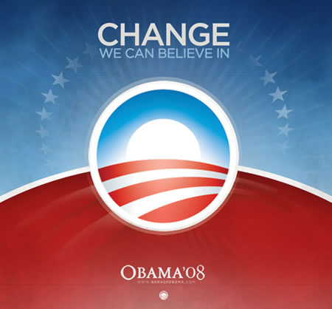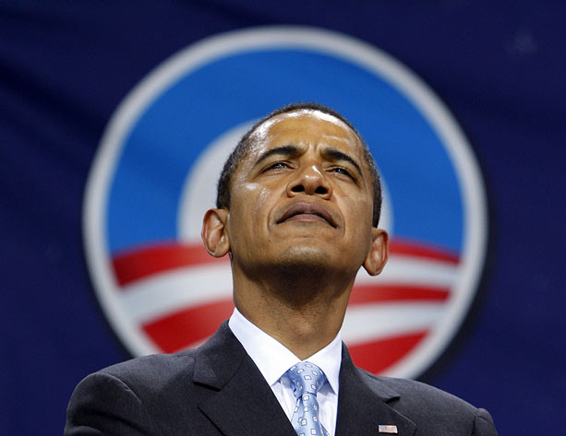

New logos were created for Obama’s campaign. The ‘O’ of Obama’s name was highlighted on all advertising. Then there was the ‘rising O’ on his logo with a blue halo rainbow encircling it. According to many historians, anthropologists, pagans, occultists, so forth, the rising sun a big pagan power symbol as it is a sign of Lucifer (son of the rising sun). Put a halo around it and it could be interpreted as a ‘sun to the second power’.

Do you see the ‘halo’ around Obama’s head in the last picture above? It is a subliminal message portraying him with some kind of ‘holiness’ or ‘godliness;.

Putting halos around peoples’ heads (politicians, ‘saviors’, popes, leaders, biblical figures, so forth) is an old propaganda trick. There are other related propaganda tricks as well such as the use of orbs in illustrations and illuminating persons with light. All of these propaganda techniques go back thousands of years.

Here’s some more modern versions of these old propaganda tricks:

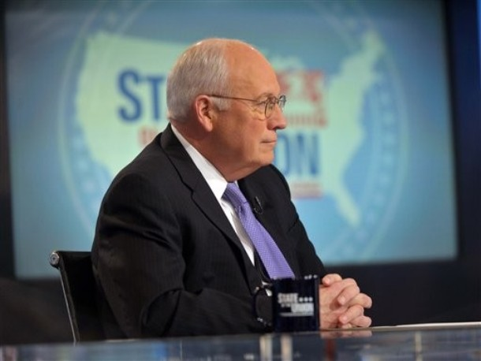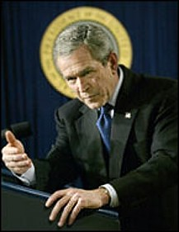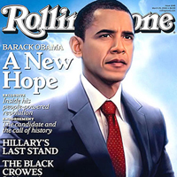
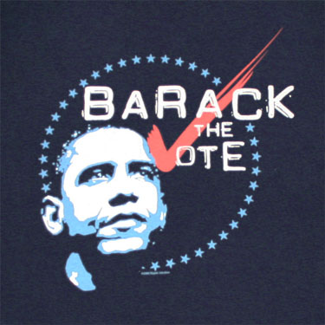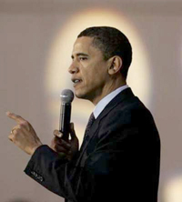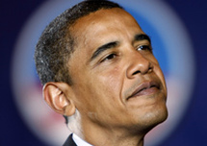
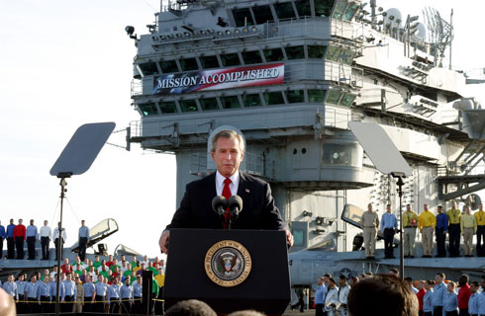

More, on the Obama logo, there are five red and white stripes that go from left to right. Numerologists will tell you that five is the number of man.

The number five is the number of the points of the pentagram. It is the number of the pentagon as well. There is the 5th Element, the Quintessence of the Alchemist. The number five has many more occult meanings and I suggest you Think for Yourself and research this.

As for the ‘rising sun’ pagan symbol, check these out:
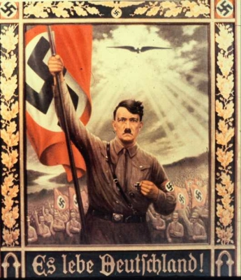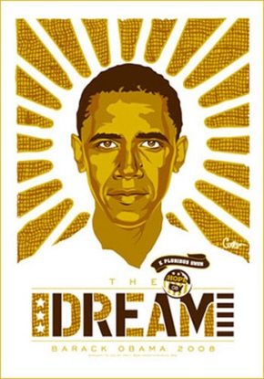
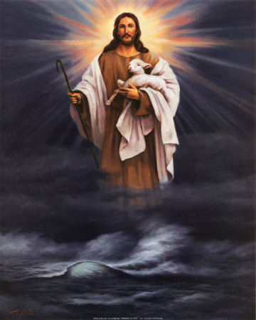

The Savior Syndrome

Since the beginning of this world, ruling elites have sowed and entrenched the idea of a ‘savior’ to save the village or country or humanity from all kinds of evils when the idea of a savior is evil because it convinces people to hand over their power (including spiritual power) to someone else who usually abuses that privilege of power.

There were ‘saviors’ in the Old Testament thousands of years before the New Testament was written and centered around one savior: Jesus Christ. These biblical ‘saviors’ were usually the old, ‘wise’, wealthy desert patriarchs or Jewish kings.

Many of these ‘saviors’ were pediophiles whotook young girls as wives and concubines and were warmongers that ruthlessly slew whole armies of non-Jews, plus then razed whole villages and cities of their ‘enemies’. It is psychopathic thinking that a ‘savior’ must kill to ‘save’ and it is Orwellian thinking that a ‘savior’ or leader must wage war to gain peace.

Waiting for someone to save you and/or the world delays real human action for truth and justice. More, it continues to deepen the traditional, established, esconced power of this world which is mostly psychopathic.

Wishing for a ‘savior’ is negative, impoverished thinking. Waiting for a ‘savior’ to rise or materialize can foster apathy and again, delay and laziness to solve the evils and/or problems of the world.
People – good, decent and innocent people - are starving, suffering and/or murdering each other for various reasons (foremost for their ‘leaders’, power, greed and religion) right now as you read these words.
To believe that only a world savior can stop this suffering is to give the problem to a politician or cleric who, as history has shown us again and again, will do nothing about it. This lethargy allows you to ignore the millions of cries of human pain that scream out to the universe every second of every day.
Like Jesus used to teach and what I teach as well, “We are our own Savior. The Savior is within ourselves.”
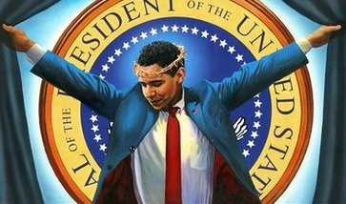
Conclusion
As a psychologist and theologian, I understand why many people believe that Obama is either a savior or the anti-christ. Their minds have been raped by propaganda pandering to their desires for change from corruption. Their minds have been raped by the subliminal messages and pagan power symbols plus outright claims that Obama is a ‘savior’ and ‘messiah’. Obama was sold as ‘divine’ with halos, orbs and illumination. This was not only violence of the mind but violence of the Soul.
When ‘saviors’ turn out to be evil, people start to wonder what happened and if the ‘savior’ is the anti-christ if he has a lot of power and/or wealth. Barack Obama is the president of the most powerful country on the earth and he sits on the United Nation’s Security Council.
Obama is nobody’s savior, except a savior for the elite and the status quo. Except for religious fundamentalists, the people of the world have become too cynical and critical to embrace a world savior, even at the point of a gun.
If Saint Malachy was right, there isn’t enough time to groom and segue a one-world leader to power. Besides, the people of the world won’t allow it. The proactive change and promise of an anti-corrupt world that Obama swore to and didn’t deliver sealed the fate that there won’t be an anti-christ.
A ‘one-stop’ antichrist would have to be everything to too many people. He’d have to appeal and be acceptable to all the world’s religions and social groups of people. Obama doesn’t do this. Except for religious fundamentalists, most people of the world are too cynical and critical to accept a one-world leader.
And there are countless reasons to make the global population cynical and critical, and thus resistant to embrace any single person to ‘save’ and/or lead the world: Broken campaign promises; hypocrises and scandals of world leaders; Climate Gate; theft of the world’s resources by wal-street; escalating wars; constant ‘terrorist’ threats; the swine flu hoax; and on and on.
People are waking up. They’re getting tired of being terrorized and controlled by fear from the media and leaders. They’re starting to see the patterns of the established control systems for what they really are.
Because of his ‘savior’ deceit, Obama might have saved the world a bigger problem: The emergence and ascension of a real anti-christ. This abstract, reverse ‘saving’ doesn’t make him a savior, though.
He’s still a puppet.

Martha Rose Crow is a regular contributor to UNCENSORED Magazine. She also manages 103 blogs that offer reference material to help people ‘Think for Themselves’. You can access these blogs through her anchor blog at http://martharosecrow.blogspot.com and she can be reached at greathierophant@yahoo.com
Martha has begun her New Year by writing a book ‘Political Ponerology, the Amplified Version’ with her close friend Judyth Vary Baker for Red Pill Press (http://www.qfgpublishing.com/).
Political Ponerology means ‘A Science on The Nature of Evil adjusted for Political Purposes’. In other words, it is a science that examines psychopathy in politics, systems and societies.

