Seven Dials

or

The Box

by Roland Michel Tremblay

Idea for a sci-fi Film

This idea on the Net: www.themarginal.com/sevendials.htm
Download a doc version: www.themarginal.com/sevendials.doc
rm@themarginal.com www.themarginal.com

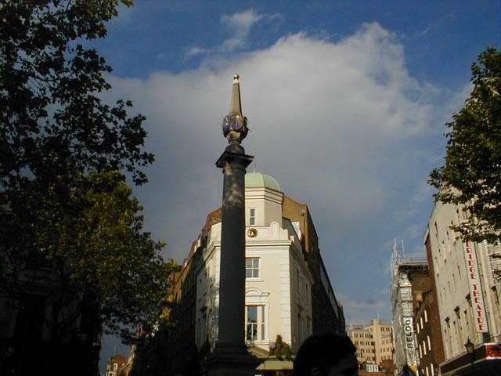

Short Synopsis of Seven Dials

Seven Dials is a monument located in the middle of a small intersection in Covent Garden London where seven streets meet. In each direction there is a different dial carefully designed to show the right time throughout the day. On the corner there is a Café called The Box where most of the story is happening. Raymond or Ray is the anti-hero of this story and he accomplishes himself in the universe of alcohol, clubs and theaters of London. He is an American living in England but facing deportation.

The film is happening in seven days and each morning Ray is waking up near the monument in front of a different street to find his world completely different from the previous day. The first day starts with him trying to offer a beer to that old tramp woman who is always sitting on the monument but she refuses categorically. Then he goes into the Café where we learn that he has reached rock bottom: he is just a customer of the Box Café with no place to live and a destroyed Renault 5 that we can see outside in the window. He has a criminal past that he is not proud of, a friend Marlene who is working at the Box and his best friend Paul who owns the Café. That first day he meets with the people who could give him the money for his new play to be produced in London but he fails to get it because of his dodgy past.

The next day he wakes up in front of the second street and there is that old woman standing beside him. She tells him that today is a new day and that for the first time she will accept a free beer from him. On entering the Café he realizes to his amazement that he now owns the café, that his play his going to be made in the theater on the Seven Dials, that his flat is upstairs with a great view on the monument and that he is married to Marlene and no longer facing deportation. He is going to struggle understanding and adapting to his new reality.

On the third day he becomes very powerful as he now owns 180 The Box Cafés across Europe and his successful play has been translated in many languages and is being presented worldwide. On the fourth day he is recognized for his greatness and huge heart toward society and human kind. His different charities have made millions to help everyone and he is perceived in certain quarters as a saint. On the fifth day he is the first ever American to become Prime Minister of the United Kingdom and is recognized as the best politician there ever was. On the sixth day he is going to the Moon, special invitation from the new British Space Agency that he helped create. On the Moon he will have a spiritual life changing event. On the seventh day everything gets back to normal, he is the low life he was on the first day, but he is a new man and he will change his destiny.

The problem is that as he climbs the social ladder and becomes almost a saint, his bad personality or who he is has not changed, he is still the same thug he ever was and needs to adapt to his new reality as the days go by in order to keep it all together without anyone realizing the fraud he is.

The old woman, a tramp, sitting at the monument all day long appears to be the only constant element throughout the seven days, and she sorts of become his conscience. Raymond is finding himself in a situation where he can change his universe but he will have to learn to change his own personality if he wants to maintain together the different elements of his existence.

The movie is a sad demonstration of human limits, but equally the creation of a modern boiling London. A generation without future that lives without God, without pity, drunk to full capacity for days without seeing the existence. The day of the awakening is death. Until, at least, Raymond becomes schizophrenic and alienated. That makes it possible for him to transpose his mind to another corresponding life in a parallel universe, so he thinks anyway.

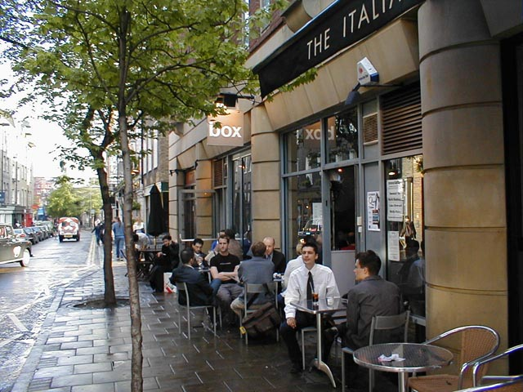

General Comments

This idea comes from a novel I am writing in French that is almost finished, the title is The Box on the Seven Dials. The premises are the same but a lot of the story has changed, and some more ideas could be taken from the book.

Though the Café The Box exists at the Seven Dials in London, this story is completely fictional. This movie is about parallel universes but I don't think I would like to jump into the science even if the topic will be discussed in the movie. I feel that it could be the result of alienation and schizophrenia on the part of Raymond. So to bring technology to justify the changes in his life would not work well and would require extensive changes to the present story. Extraordinary events like being American and becoming Prime Minister in the UK, going to the Moon or enjoying so much success would be acceptable if Ray was schizophrenic and had hallucinations. It would not be plausible if he just found himself in a parallel universe as even there these events would look too fantastic.

The old woman could be the start of an explanation, she might not be who she appears to be, she could have the power to make the shifts happen and she would know what is happening to Ray, even though it will never be clearly said. She will offer guidance without being too explicit.

Sometimes the best sci-fi movies are the ones that have these weird events happening without too much explanation and perhaps this is what should be done here. I understand that an eventual team might want to make it more sci-fi and I have written a lot about the subject of parallel universes in my reports. You can draw some inspiration from my main report on the subject and I am ready to change the story accordingly to include a device of some sort that could be applied to Raymond each night when he falls asleep on the monument:

Parallel Universes: www.themarginal.com/paralleluniverses.htm

If going to the Moon in a rocket ship turns out to be too expensive or time consuming, Ray could have his spiritual vision anywhere else, like perhaps in Kew Gardens or the ruins of King Arthur's castle in Cornwall. He could also go directly from the monument to the Moon, transported somehow by the old woman standing beside him without first being launched into a rocket ship.

This film should be modern and show the great life of London. It can be a tremendous opportunity to get across the screen for the first time what life in London can really be about, why so many young people from all around the world end up there for many years. I experienced that life first hand, I worked in that Café at the Box for months until they sacked me and it was the best time of my life.

Synopsis of Seven Dials

Day 1 - Ray the Miserable

This film starts with a view of London from the sky, moving towards the Seven Dials where we can clearly see the seven streets meeting at the monument. Perhaps we could see Raymond still sleeping on the monument with the old tramp woman beside him.

Then we do a close up to Ray waking up. We can see his exploded Renault 5 in front of the café The Box, a theater on the other side and the nice apartment with big windows directly above the Seven Dials.

Ray looks at the old woman and tells her that she should find something to do instead of wasting her time sitting in the Seven Dials all day. He tells her that for the first time he will buy her a beer if she could just disappear for the rest of the day. She reminds him that she does not want charity, she just wishes to live peacefully in the area. Ray goes inside the Box.

Inside the Café we meet Marlene the waitress and Paul the owner, both best friends of Ray who remind him that if he continues to sleep outside like that, he will die of a sickness or something. Paul reminds him that his apartment upstairs is always open and he should go and sleep there. Ray is too proud even though he has nowhere to live and that he no longer has is only possession, his Renault 5. They discuss who might have destroyed his car and even though Ray has a good idea he does not want to say. Marlene tells him that he has to stop living like that, next time it will be his life that they will take. Paul finally concludes that it was a good thing since Ray does not have a driving license and was caught twice by the police driving illegally and under the influence of alcohol, which does not help his status as an American immigrant in the UK as he now faces deportation. Ray tells them that today is the big day and might mark the end of his criminal life. He is going to eat in a chic restaurant with his future producers to get the money for his wonderful play that he would like to direct in the West End, on the other side of the Seven Dials in fact.

At the chic restaurant we see Ray explaining to some important people what the play is about and how he sees it. They are impressed and are very interested but they have heard of his criminal links and they know his car exploded the day before. It looks too much like a risk and they are not willing to fund his play.

Ray goes back to the Box for a nice night out with his friends in a packed Café where alcohol flows freely. He falls asleep completely drunk on the monument in the middle of the Seven Dials.

Day 2 - Ray the Successful

The next day he wakes up in front of the second street and there is that old woman standing beside him. She tells him that today is a new day and that for the first time she will accept a free beer from him. So he invites her in hoping to get rid of her for the rest of the day.

On entering the Café he realizes to his amazement that he now owns the café, that his play his going to be made in the theater on the Seven Dials, that his apartment is upstairs with a great view on the monument and that he is married to Marlene and no longer face deportation. His car outside that we can see by the window is the latest Mercedes model and Paul is now an employee of the Box.

Ray is struggling to understand and adapt to his new reality and does not believe it until he sees the cover of Time Out and the Evening Standard. They both praise his new play and we can see a photo of him with his wife Marlene at the premiere. They go outside to see the sign in front of the theater, there is no two ways about it, it is his play, his friends are not lying. They also show him his new Mercedes parked in front of the Box. How did he get the money? People were rushing to invest in the play, everyone knew it was going to be a success. His criminal past does not appear to exist anymore and it looks like he is no longer an alcoholic as everyone is surprised when he asks for his first pint of the day. He decides to go and visit his apartment upstairs, leaving the old woman with her beer in the middle of the Seven Dials.

His apartment does not look as nice as it will on Day 3 but it is enough to impress Ray completely. He decides to break some vase and glasses, turn everything upside down so it looks more like what he used to be in the past. After he destroyed half of the apartment, he says that now it reflects his own taste and personality.

He then gets a phone call, they need him at the theater next door to sort out the last details for tonight's presentation. The Queen will be there and many important journalists from the worldwide press. Ray has changed into something very classy and as he crosses the Seven Dials to get to the theater, the old woman with her beer in her hand looks at him with a big smile. He feels unease about this and finally meets the cast.

This is his dream come true and he looks at everything in wonder, barking orders at everyone who are surprised by this burst of authority. Marlene appears and tells him that something must be wrong as usually he is very nice with everyone. After that he tries to be nicer with everyone. He looks at the alcohol available at the bar and resists the temptation to get a drink. He is trying to be the nice person that everyone believe him to be.

The audience arrives and the journalists are coming right to him for interviews before the curtain goes up. He is a bit embarrassed as he does not know much about how everything happened and the journalists appear to know more about it than him.

After the presentation it is the big party where Champagne is distributed around as they get the early edition of the newspapers that tell how great the play is and how satisfied the Queen has been. Then it fades to Ray waking up on the monument on Day 3.

Day 3 - Ray the Powerful, owner of a chain of cafés

On the third day Ray wakes up in a panic, perhaps it was all a dream? Perhaps he has lost everything and he is still facing deportation? The old woman comes to comfort him and she says: don't worry, look, your Mercedes is still there, intact.

He rushes in the café to find out that he now owns a chain of 180 The Box Cafés throughout Europe. He learns that his play has been translated in 26 different languages and is produced worldwide. When he rushes to his apartment, everything looks much nicer than the previous day. He finds his bank account and tries to understand how much money the long number of his balance equals to. He cannot believe this amounts to million of pounds.

Every newspapers talk about him, he is even on TV on the news. He decides that this is a great day and as Marlene enters the apartment, he invites her to the most expensive restaurant in town. When they arrive there they are treated as celebrities, they are quickly moved to the VIP lounge where they receive a first class service. Ray and Marlene are living a dream that suddenly evaporates into Ray waking up again for his fourth day.

Day 4 - Ray the Saint meeting the Pope

On the fourth day the old woman tells Ray that today is the day of reckoning. She asks him if he is ready to become a martyr. Ray does not like that, he suddenly wonders if everything has come to an end or perhaps has taken a turn for the worse.

As Paul and Marlene are coming toward him, Ray feels sick. He is rushed to his apartment by Paul who tells him to get ready for the press conference and for his departure for Rome. What? Ray is trying to find out what happened, why is he suddenly a martyr? Paul looks puzzled, he tells him that he is more like a Saint than a martyr, his numerous charities have broken the roof, he has made millions and helped millions. He is recognized for his greatness and huge heart toward society and human kind. The Pope wants to meet with him later today in reconnaissance for all his hard work for the different communities in the world, especially in Africa. Ray cannot understand as he never cared for dying Africans or charities.

At the press conference he is making a lot of mistakes, his true nature is fighting to get back on the surface. We can almost hear in his speech and answers to journalists' questions that charities is the last thing on his mind and that people should help themselves as he did. But he quickly changes his tone and words after a moment of panic amongst the crowd. At the end he says to Marlene that this was the most difficult thing he ever did, saying all these things that he does not believe in. Marlene brushes it aside, telling him to stop fooling around, they have a plane to catch.

While waiting to catch the plane, Ray is going berserk. He remembers the press conference and he does not wish to find himself in a situation where he would have to lie to the Pope. Even though he says that he has no morale or ethic values, lying to the Pope will certainly bring him straight to hell. He decides that he does not wish to speak to the Pope, he gets off the plane before it goes off. He says that it does not matter anyway as tomorrow all this will no longer exist.

He decides to go on an alcohol binge and we can see him later in Kew Gardens with Paul, discussing what is happening to him, if he can carry on pretending to be someone he is not. He also discusses how it is possible for him to find himself in what looks like parallel lives in parallel universes. Paul suggests that perhaps he is just schizophrenic and it is all in his mind. At which point Ray drinks some more.

Day 5 - Ray the best Politician there ever was

On the fifth day Ray does not want to open his eyes. He is facing yet another street on his fifth day and he does not want to start the craziness that his life has become. The old woman is nowhere to be found and he sees a big black car where his Mercedes used to be. He says: now what?

As he is struggling to get into the Café, he cannot find anyone in it. He looks at the newspapers and he appears on the first page. He reads aloud: The first ever American to be Prime Minister in this country, made possible by a change in the law because of his popularity. Since Ray has come to power, the United Kingdom has taking its right place as the most powerful nation in the world, succeeding where America failed in bringing peace to the Middle East and the world. Then he goes on reading a list of his latest accomplishments: The country has never been so rich, taxes have been virtually eliminated, the unemployment rate has never been so low and the new structure of the National Health Services is a success. The rest of Europe is copying the UK and their efforts are met with the same degree of success.

Ray cannot believe his eyes and is not impressed. When his chauffeur comes in to bring him to the Parliament, Ray's first reaction is to refuse. Then he appears to have an idea, he will have fun today. His chauffeur asks him if he would first like to change as he is wearing jeans and a T-Shirt, to which Ray refuses. He wants to be noticed on his way in to the parliament.

When they arrive at Westminster, he is refused access because no one recognizes him. When he starts shouting that he is the Prime Minister, their savior and whatever, the security guards recognize him and apologize for the mistake. Then we see a batch of journalists rushing to interview him and as the security guards are pushing him in so he can avoid the journalists, he tells them to let them come, he has a series of announcements to make.

His speech goes along those lines: I have decided that people in this country have it too easy. From now on everyone will give half of their salary to the government, the National Health Services will get back to the poor conditions it was in before I came to power, it should give the patients a great lesson about life, we will cut jobs in every government agencies and we will build a greater army that will take back England's old colonies and conquer the rest of Europe.

When the journalists start to laugh as they think this is a good joke in order to show how bad things were before he came to power, he explodes and hit a journalist after destroying her camera. He takes the gun of a security guard and starts shooting the journalists. We see the bars of his cells closing as he sobs in despair in prison.

Day 6 - Ray is going to the Moon

On the sixth day Ray is pleased with his accomplishment of the previous day, he is still laughing. The old woman comes to him and asks what he is doing with his life. Who is he, really, and as he ever wondered? She wants to know how his life could have been and was not, because he was a simple criminal with no desire to live whatsoever. He tries to defend himself, he says that he wanted to direct his play, he could have become someone and do great things if only they had given him his chance. She tells him that today he is going to have a life changing experience. A spiritual adventure. He should get ready.

A car stops right in front of them, he is invited to come in. They are going to the launch pad of a rocket that is going around the Moon and back to test the new British Space Agency technology. Because of all his help in creating the agency, he is going to the Moon as an observer. Ray stops for a second to consider all this, and answers: well, this is worth living.

So they install him in the rocket, it is launched without problems and it goes around the Moon. On the other side of the Moon Ray finds himself no longer on the rocket but walking on the Moon without a space suit, but he can breathe with ease. He looks around in wonder, looks at the Earth, and the old woman appears beside him. She transforms into a young and beautiful angel, saying that she is the Virgin Mary. Ray starts to cry as Mary starts to speak softly. She tells him that this could be his reality, if he wants it. That he can do whatever he wants with his life. You can dream and you can make your dreams come true. She disappears and Ray finds himself on board the rocket, still crying, and they go back toward the Earth.

Day 7 - Ray the New Man

On the seventh day everything gets back to normal. Ray is once again the low life he was on the first day, we can see his destroyed Renault 5 in front of the Box. The sign in front of the theater is no longer his play. He quickly walks inside the Café.

When he enters he finds Marlene with a tray in her hands and Paul at the back of the bar, he appears to be the owner. Ray asks if anyone saw the old woman today, nobody did. He is happy and when Paul asks him if he wants a pint of beer, he answers that this a new day, he wants a cup of coffee. Today is the day and he will get the money for his play. Marlene is very excited. Ray asks her if she wants to come and she agrees. He asks her if she wants to marry him, and she accepts with tears in her eyes. Everyone is happy, this is the end of the film.

Roland Michel Tremblay

44E The Grove, Isleworth, Middlesex, London, TW7 4JF, United Kingdom
Tel: +44 (0)20 8847 5586 Mobile: +44 (0)794 127 1010
rm@themarginal.com www.themarginal.com

